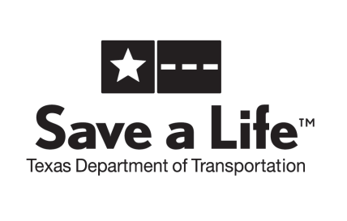 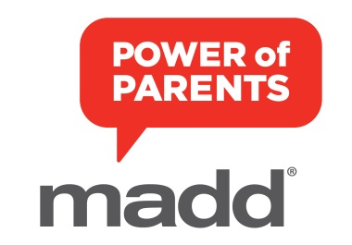

**MADD Back to School 2014**

***Power of* *Parents* Fact Sheet**

***Did You Know?***

* 73 percent of Texas teens claim the fact that most or all of their friends drink motivates them to drink.
* More than half of Texas teens say that the fact that their peers are drinking to get drunk also motivates them to drink.
* Yet, 62 percent of both Texas teens and parents believe it is unacceptable to drink under the age of 21.
* Nearly three out of four teens are aware of parties where a parent or adult has provided alcohol to teens.1
* Teen alcohol use kills about 4,700 people each year, more than all other illegal drugs combined.2

***Parents are biggest influence on teens***

* Teens are 80 percent less likely to drink if parents deliver a clear no alcohol before 21 message.
* Yet, 65 percent of parents say it’s ok for teens to have alcohol at Thanksgiving.
* Parents have the biggest influence on their teen not to drink, even more so than their friends.

*PowerTalk 21* is sponsored by Nationwide Insurance. In Texas, the program is supported by the Texas Department of Transportation.

***Power of Parents***

Parental influence is the most important factor in helping keep teens safe*.* A GfK Roper Youth Report showed that 74 percent of kids (8-17) said their parents are the leading influence on their decisions about drinking. That’s why MADD began an underage drinking prevention initiative, beginning with a community-based parent program, *Power of Parents*, developed and launched with the national sponsorship of Nationwide Insurance. MADD has partnered with Dr. Robert Turrisi from Pennsylvania State University and adapted his handbook model to reach parents of high school students. The parent handbook is the cornerstone of this community-based program and will be available free to communities through the website and through 30-minute parent workshops facilitated by trained MADD staff and volunteers.

MADD offices throughout Texas are hosting workshops to help parents learn more about PowerTalk 21 and the Power of Parents program. Contact your local MADD office for more information or visit madd.org.

***Mothers Against Drunk Driving*®**

Founded by a mother whose daughter was killed by a drunk driver, Mothers Against Drunk Driving® (MADD) is the nation’s largest nonprofit working to protect families from drunk driving and underage drinking. MADD also supports drunk and drugged driving victims and survivors at no charge, serving one person every eight minutes through local MADD victim advocates and at 1-877-MADD-HELP. Learn more at [www.madd.org](http://www.madd.org/) or by calling 1-877-ASK-MADD.

***Tips for Connecting With Your Teen***

**1. Communicate Before a Problem Starts**

* Have important discussions now, before there’s blaming, anger or punishments.
* Agree on a time to start talking together about the dangers of alcohol.

**2. Discuss Rules and Consequences**

* Explain how you expect your son or daughter to act, and why.
* Tell your teen plainly that you don’t want him or her drinking.

**3. Show You Care**

* Gently touch your teen on the arm or back to show affection.
* Tell your teens you love them and want them to be healthy and safe. Explain that’s why you need to talk together about the dangers of underage drinking.

**4. Pay attention**

* Even when life gets hectic, take time out to listen to your teen.
* Monitor where your teen is and what your teen is doing, constantly.

**5. Share Family Activities**

* Have dinner together at least three times a week.

**6. Give and Respect**

* When your teen talks to you, listen and reply respectfully.
* Insist that your teen treat you with respect, too.

**7. Enforce Consequences Consistently**

* If your teen breaks the rules, stay calm and enforce the consequences.